TryHackMe Writeup: Pyramid of Pain
1. Objective
The objective of this room is to understand the Pyramid of Pain and learn how cybersecurity analysts use indicators of compromise to detect malicious activity.
2. Introduction
When attackers compromise a system, they may leave clues such as suspicious files, IP addresses, domains, and unusual behaviours. Security analysts use these clues to investigate possible attacks.
The Pyramid of Pain explains that some indicators are easy for attackers to change, while others require more effort to change.
3. What Are Indicators of Compromise?
Indicators of Compromise (IoCs) are clues that may indicate malicious activity on a system or network.
Examples include:
- Suspicious file hashes.
- Malicious IP addresses.
- Domains associated with malicious activity.
- Unusual files or system artefacts.
- Evidence of attacker tools or techniques.
An IoC is a clue, not automatic proof of an attack. Analysts should investigate it in context.
4. Six Levels of the Pyramid of Pain
1. Hash Values
A hash is a value calculated from the contents of a file. Security tools can use hashes to identify known files.
Example: A file hash matches a known malicious sample.
Limitation: An attacker can modify the file and produce a different hash.
2. IP Addresses
IP addresses can help identify suspicious network communication.
Example: A computer connects to an IP address reported as malicious.
Limitation: Attackers can change infrastructure, and IP addresses may be shared or reassigned.
3. Domain Names
Domains may be used for phishing, malware delivery, or communication with attacker-controlled systems.
Example: A device repeatedly queries a domain associated with a known malicious campaign.
Limitation: Attackers can register new domains or change existing infrastructure.
4. Network and Host Artefacts
Artefacts are traces left by activity on a network or system.
Examples include unusual DNS requests, suspicious files, unexpected registry entries, or abnormal system activity.
These artefacts can help analysts understand what happened during an investigation.
5. Tools
Attackers may use tools to scan networks, access systems, or perform other malicious activities.
Security analysts can investigate tool-related activity and determine whether it is authorised or suspicious.
6. Tactics, Techniques, and Procedures (TTPs)
TTPs describe how attackers operate.
- Tactics: The attacker's goal.
- Techniques: The method used to achieve the goal.
- Procedures: The specific way the method is carried out.
For example, an attacker might use phishing to steal credentials and then attempt to access other systems.
These behaviours can be harder for attackers to change completely than a single hash or IP address.
5. Why Is the Pyramid Important?
The Pyramid of Pain helps defenders understand why behaviour-based detection can be valuable. If a security team relies only on a single file hash, an attacker may avoid detection by changing the file.
Monitoring multiple indicators and attacker behaviours can make detection more resilient.
6. Importance in SOC Analysis
SOC analysts use IoCs to investigate alerts, search logs, identify related events, and decide whether further action is needed. They may also compare observed activity with frameworks such as MITRE ATT&CK to understand attacker techniques.
7. What I Learned
I learned what IoCs are, the six levels of the Pyramid of Pain, and why detecting attacker behaviours can be more useful than relying only on individual indicators.
8. Conclusion
This room helped me understand how threat intelligence supports security monitoring. Using multiple indicators and investigating attacker behaviour can help security teams identify and respond to suspicious activity.
9. Evide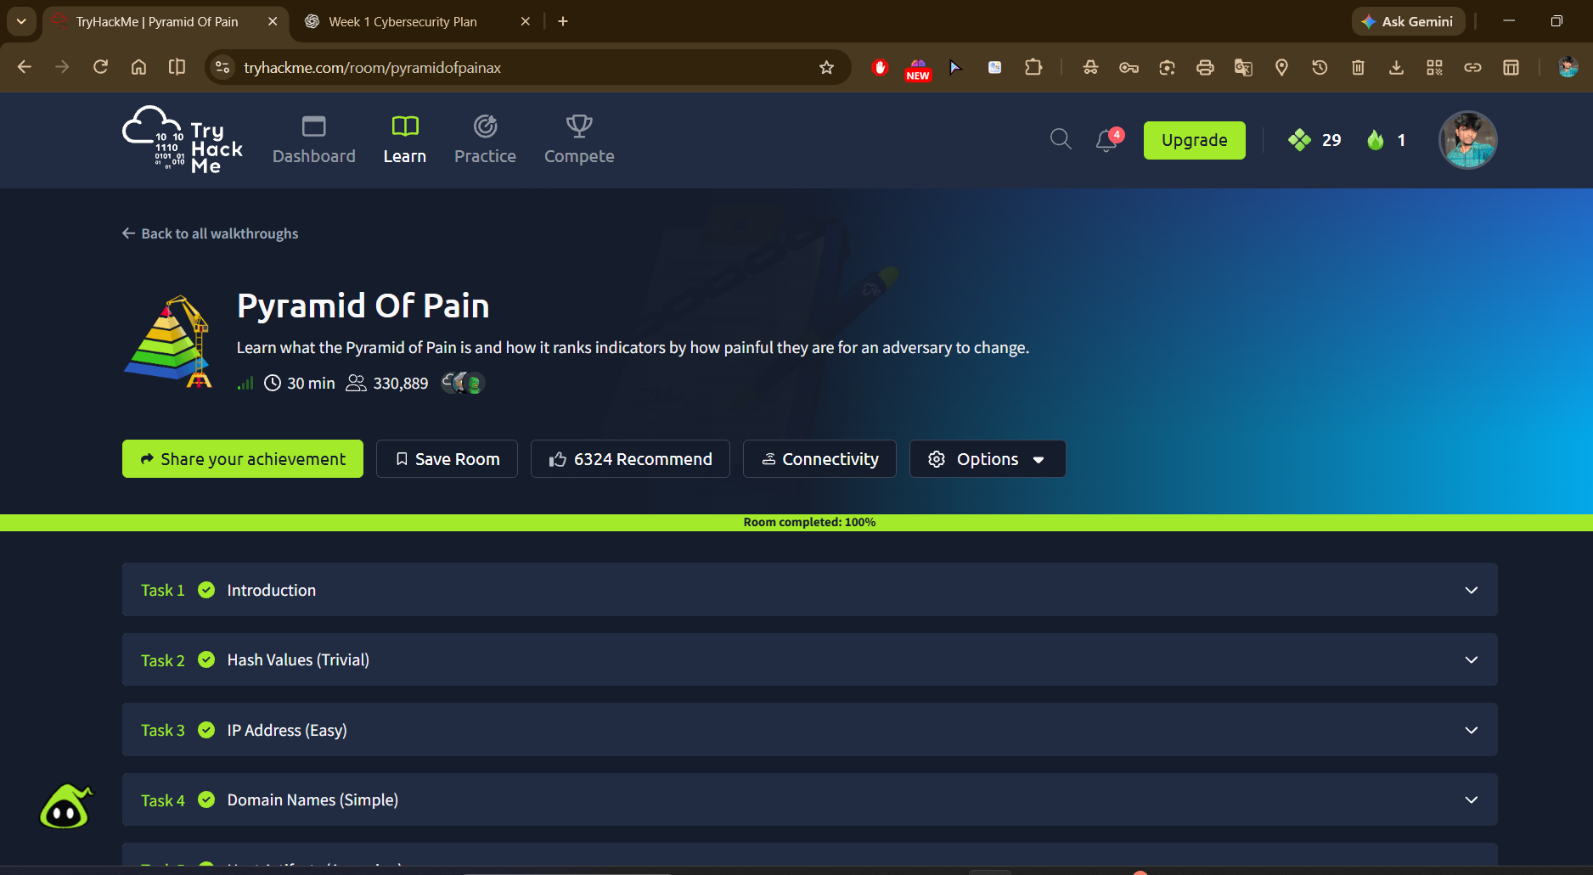nce

